SWINBURNE UNIVERSITY OF TECHNOLOGY
COS30043 Interface Design and Development: Individual Report
OpenTexila Student Management System (Vue 3 frontend)
Aung Moe Thu (105292899) | Group G7 (with Show Wai Yan and Chia Kar You) | Live application: https://opentexila.site

1. My contributions
I authored 41 non-merge commits in the frontend repository between 26 October and 14 November 2026. I also reviewed and merged pull requests written by my teammates, but those are not claimed here. The group report describes the shared design system and the pages as a whole, so the table lists only what I built myself.
Foundation | Project setup with a feature-based folder structure, the shared design-system styles and app shell, and the Docker build (85e9dde, 6baa7a8, 08da10b, 830fb5f). Later, the per-role home routes (df8f161) and the teacher-to-lecturer rename across the codebase (81b1b50).
Landing page | Redesigned WelcomePage.vue with a hero section and phone mock-up, a three-step "How it works" row, role cards and a call to action (37a82e0).
Dashboards | Admin home with live counts and today's sessions, restyled lecturer home with ClassSessionCard and QuickAccessCard, and the student home now showing Today's classes first (5c9bf12, 793ceff, 20c5253, ca3a583).
Announcements | All-classes feed with search and filters (use-announcement-feed.js), lecturer form with validation, and a detail page with LikeButton, CommentForm and CommentList (61031f7, 5fba42f, 428ebe1).
Accounts | Admin Create account page with a generated temporary password, a one-time password card, a reset-password dialog and a searchable user list (7def497).
Courses and classes | Admin course and class lists, forms and validation, with the reusable FormField and use-paged-list.js (f1387af). Class form suggestions for term, room and section (7ec733e).
Sessions and attendance | Class schedule list and session form (c43678f), schedule conflict warnings (c228138), session time input fixes (e1b85ca), admin class attendance pages (8053876), lecturer assigned classes page (4a67219), and the student check-in page (12a8910).
Advanced feature | Map-based geofence editor, per-session attendance settings and the "Try a check-in" simulator (45ee8e5, 29b924c, ec33d90, 42a22c7; pull request #52). See Section 2.
Quality and final fixes | Test suite reorganisation with shared class-list contracts (b248879), accurate-location waiting at check-in (0b07ac9), maximum late allowance (c5e58c6), class list filters kept after saving (c1b7dfe), status filter (3f02120), Term list on My classes (8a89566), page title and favicon (9815809).
 | 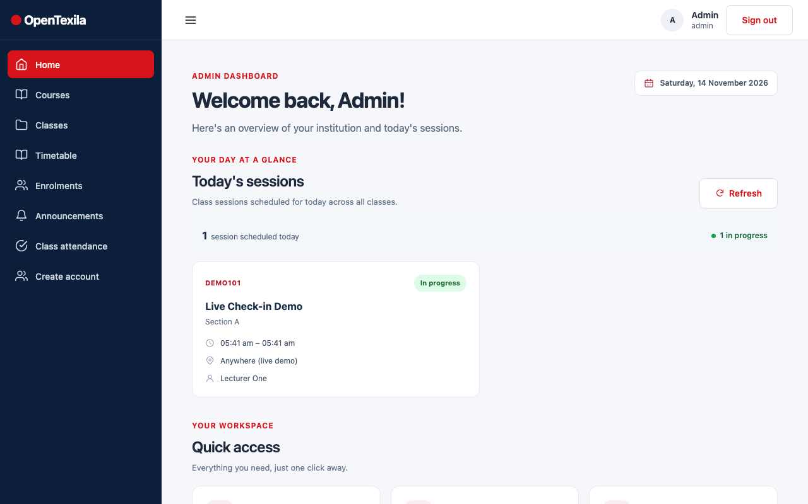
Figure 2a. Landing page I redesigned. | Figure 2b. Admin home I built, with counts and today's sessions.

2. Advanced feature: map-based geofence editor with a check-in simulator

2.1 What it is and why I built it
Attendance in OpenTexila is location based: a student can check in only inside a circle around the classroom, during the session window. Before this feature, an admin had to type a latitude, longitude and radius as bare numbers. That is hard to do correctly, because nobody can tell from "-37.822, 145.0388" whether the circle covers the room, the building or the car park next door. A wrong value either locks students out or lets them check in from outside. The administrator is the user who carries this risk, so the interface should let them see the result before saving.
I replaced the number-only fields with an interactive map (Figure 1). The admin clicks the map or drags a pin, and a shaded circle shows the allowed area. The same screen has a radius slider, number inputs and a "Use my current location" button, plus per-session settings for room and late allowance. A "Try a check-in" panel lets the admin place a test student and choose a time, and then shows whether that student would be Present, Late, outside the area, or too early or late. I chose it because it turns an invisible rule into something the admin can check visually, and it reduces mistakes in the one setting the whole attendance system depends on.

2.2 Techniques used (beyond the classroom material)
- Integrating a non-Vue library with the component lifecycle. Leaflet is not a Vue library, so I wrote a composable, use-geofence-map.js, that wraps it. Leaflet is loaded with a dynamic import() inside init(), so its code and CSS are only fetched on the pages that need the map and the rest of the app stays small. It is initialised in onMounted and removed in onBeforeUnmount, which calls destroy() to stop the watcher, disconnect the observer and call map.remove(). This avoids memory leaks when the admin navigates away.
async function init(element) {
const leaflet = await loadLeaflet(); // () => import('leaflet')
L = leaflet.default ?? leaflet;
if (destroyed || !element) return; // unmounted while loading
map = L.map(element, { center: start ?? DEFAULT_CENTER, zoom: ... });
observer = new ResizeObserver(() => map?.invalidateSize());
observer.observe(element);
draw();
stopWatch = watch(() => [position()?.lat, position()?.lng, radius(), ...], draw);
}
- One source of truth with props, emits and watchers. The page owns latitude, longitude and radius. GeofenceMap.vue takes them as props (position, radius, probe) and reports changes with emits (pick, probe). The composable receives getter functions and a Vue watch() calls one idempotent draw() function, which moves the marker, the circle and the dashed line. Because the map, the number inputs and the slider all read the same props, they cannot disagree. Leaflet's map, marker and circle objects are kept as plain variables outside Vue's reactivity on purpose, as proxies around such large objects are slow and break identity checks.
- Avoiding feedback loops between map and inputs. Moving a marker from code and dragging it by hand both change the same numbers, so a naive watcher could loop. samePosition() in services/geofence.js treats two points closer than 1e-7 degrees as equal, and draw() only calls setLatLng() when the position really changed. Coordinates are rounded to six decimals (about 0.1 m) and the longitude is wrapped into -180..180 because Leaflet repeats the world sideways.
- Geometry and a rules engine as pure, testable functions. The simulator (CheckInSimulator.vue and services/check-in-simulation.js) uses the Haversine formula to measure the distance from the test student to the pin, with the same Earth radius as the server, so the preview agrees with a real check-in. A second pure function, followProbe(), keeps the test student at the same distance and bearing when the pin is moved. simulateCheckIn() then applies the rules in the server's order and returns an outcome and a plain-language sentence.
export function distanceBetween(from, to) { // Haversine, metres
const a = Math.sin(rad(to.lat - from.lat) / 2) ** 2 + Math.cos(rad(from.lat))
* Math.cos(rad(to.lat)) * Math.sin(rad(to.lng - from.lng) / 2) ** 2;
return EARTH_RADIUS_M * 2 * Math.atan2(Math.sqrt(a), Math.sqrt(1 - a));
}
// simulateCheckIn: cancelled -> not open -> closed -> outside -> present | late
- Accessibility and graceful degradation. The pin is a Leaflet divIcon drawn with CSS, so no image files are needed, and it is keyboard focusable with a visible focus ring. The map has an aria-label and tells the admin they can type coordinates instead. If Leaflet fails to load, an error notice appears and the inputs still work. If tiles fail, a warning says the entered coordinates are kept. "Use my current location" uses the browser Geolocation API with friendly messages for each error code.
- Reusable components and testability. The class form and the attendance-settings page share GeofencePicker.vue. Helper modules (geofence.js, attendance-policy.js, check-in-simulation.js) hold the rules, and the Leaflet loader can be injected, so I could unit test the map logic with a fake Leaflet (tests/geofence.test.js, check-in-simulation.test.js, attendance-policy.test.js).
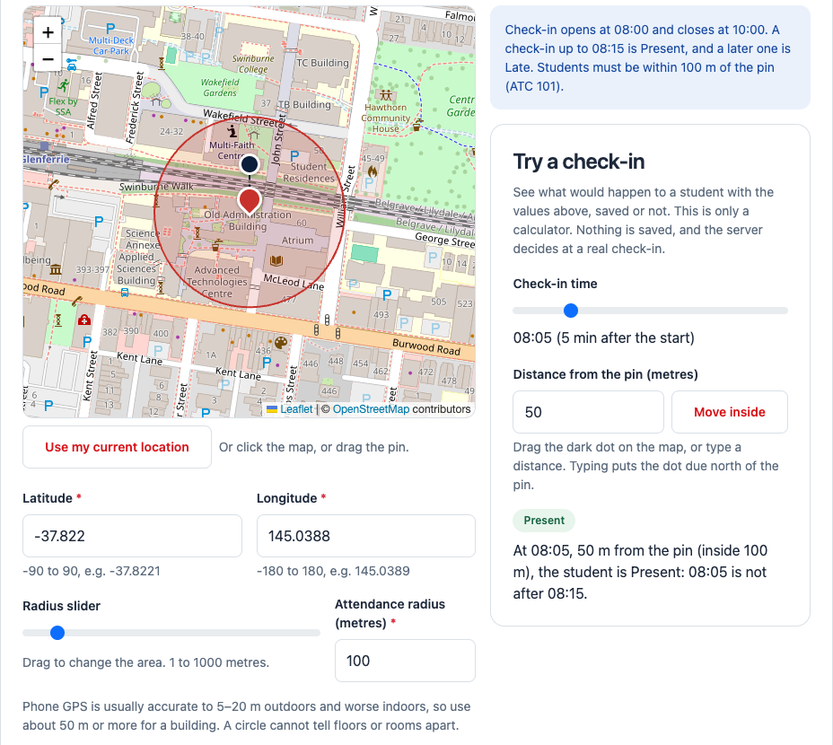
Figure 1. Attendance settings page: draggable pin and radius circle, test student (dark dot), radius slider, and the "Try a check-in" panel showing "Present" (production, 14 November 2026).

2.3 How it improves the application
The admin can set a venue by looking at the real building, check the result with the simulator before saving, and then change one session (for example a different room or late allowance) without touching the class defaults. The settings page also states the practical limit that phone GPS is only accurate to about 5 to 20 m, so a radius near 50 m is advised for a building. The feature connects the admin screens with the student check-in page, as both use the same rules.

3. Other key techniques used
- Composables for list state. Every list page (classes, announcements, history) uses a composable such as use-paged-list.js or use-announcement-feed.js that holds filters, page, loading and error state, so pages stay short and the loading, empty and error states look the same.
- Debounced, cancellable checks (schedule conflicts). use-session-conflicts.js debounces input by 300 ms, cancels the previous request with AbortController, ignores out-of-date answers with a request counter, and caches results. It warns the admin which existing sessions clash on class, lecturer or room (ScheduleConflictList.vue). The warning is advice only and the server still decides.
- Reusable, accessible form controls and validation. FormField.vue provides label, hint and error text with the correct id and aria-describedby for every input. The validation rules are plain functions in services files, so a form shows a summary banner and a message under each field. Course, class, session, account and announcement forms all use the same pattern.
- Time zones. zoned-time.js and DateTimeField.vue convert between Kuala Lumpur time (shown to the admin) and UTC (stored), and the late time is entered as minutes after the start.
- Feature-based structure and responsive layout. Pages are split into a thin page component, a composable and service functions, and I used v-if/v-else states and Bootstrap grid classes so the landing page, dashboards and forms work from phone to desktop.

4. Challenges and how I resolved them
- Radius circle did not follow a dragged pin (ec33d90). After a drag, the pin and coordinates were right, but the circle stayed at the old place. The draw function compared the new position with the pin's position, and a drag has already moved the pin, so the circle was skipped. I gave the circle its own "drawn" position and added tests for a drag, a click and typed coordinates.
- Looping updates between map and inputs. Two-way sync caused repeated updates when the map and inputs answered each other. The tolerance in samePosition() and one-way data flow (props down, events up) fixed it.
- Inaccurate browser location (0b07ac9). A phone often returns a rough first position a few hundred metres off, and the server rejects it, so students were refused. I wrote location-reading.js, which uses watchPosition, waits up to 12 s for an accuracy of 100 m or better, keeps the best reading, and clears the watch on every exit. The page also explains what to do when location is blocked.
- Session time input and overlaps (e1b85ca, c228138). A single datetime field was awkward and error prone, so I split it into a date plus 24-hour hour and minute selects. The conflict warning and a highlight of the clashing session help the admin find the overlap. A stale warning is cleared at once when the times become invalid.
- Filters lost after saving (c1b7dfe). Editing a class returned the admin to an unfiltered list. I moved the filters into the URL query (class-list-query.js), so the list opens as it was left. I also added a Term list so one term is not typed in two spellings.
- Late allowance too generous (c5e58c6). A student arriving near the end could still count as Present. I added MAX_LATE_MINUTES (30) in one file used by the settings page and the session form, and the backend checks the same limit.
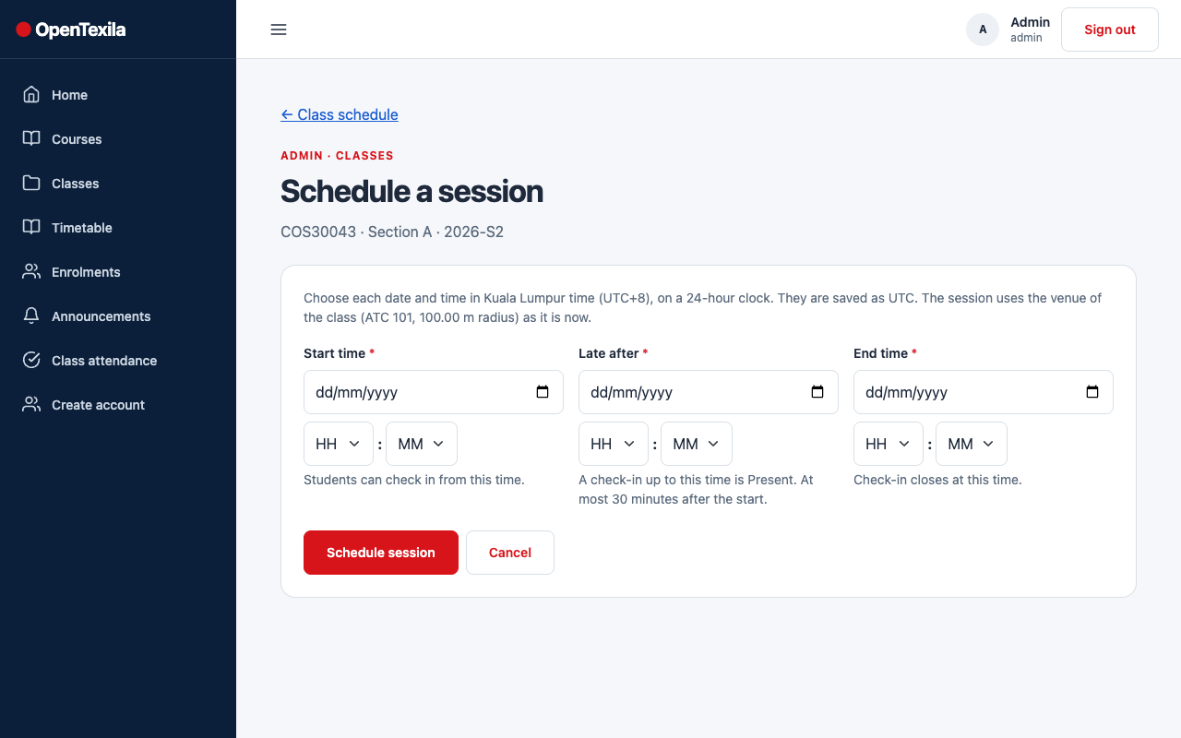 | 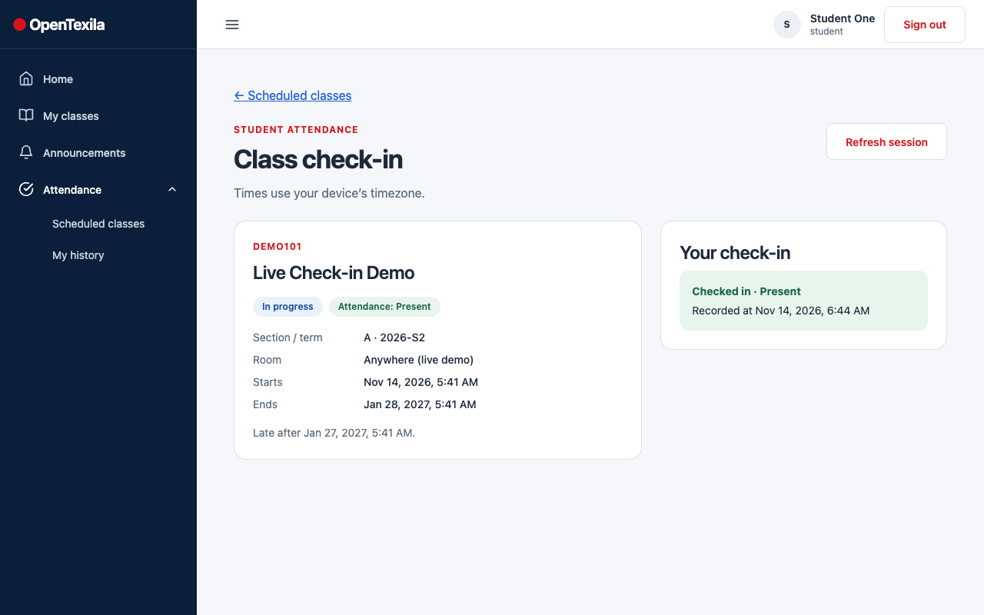
Figure 3a. Session form: separate date, hour and minute fields. | Figure 3b. Student check-in page showing a recorded Present result.

5. Reflection
This project taught me to keep the interface simple even when the logic behind it is not. Wrapping Leaflet taught me that a third-party library has its own lifecycle, and that clear ownership of the data and idempotent update functions prevent most bugs. Writing the rules as pure functions made them easy to test and to keep in step with the server. If I did it again, I would test the map earlier with real users on phones, because most of my later fixes came from real devices and real data rather than from the first design.

